Reading Bird Body Language

Introduction

Most parrots are highly vocal, using calls and a variety of sounds to establish and protect territory, attract mates, warn of danger, and maintain social connections. Parrots also communicate visually, using flashes of their colorful plumage as well as eye contact and body language.

From the tiniest budgie or parrotlet to the largest macaw, pet birds can be loving,
cuddly, playful, or contemplative 1 minute and demanding, aloof, manic, or peevish
the next. Unlike dogs, who are always glad to see you, birds can be moody.
Sometimes they want nothing more than to be left alone—in your company, but not in
your face.

Some of these moods are pretty obvious—an Amazon in a rowdy state or a cockatoo
who wants to be cuddled isn’t hard to figure out. Other times, though, behavior signs
may be more subtle, and the failure to heed these clues may earn you a nip. Sharing
space with bird is like living with a mate, or family, or roommate—sometimes you just
have to pick your moments and know when to back off.

—Brian Speer and Gina Spadofori and Brian Speer in Birds For Dummies

Careful observation of your bird’s body language can provide you with clues to when your bird is receptive to play and handling. Paying close attention can also provide information about your bird’s health.

Relaxed or Comfortable Postures

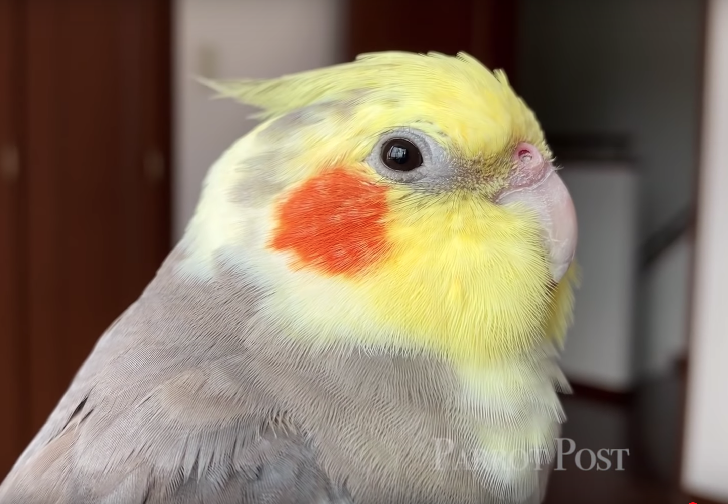 | The posture of a comfortable, trusting companion parrot has little in common with the normal, vigilant prey species. Instead, these individuals exhibit behaviors that express a sense of safety and well-being, like stretching motions and preening (or grooming of the feathers). Additional signs of contentment can include:

 | The plumage appears a little soft. Feathers are fluffed* and blend together.
 | Beak grinding | 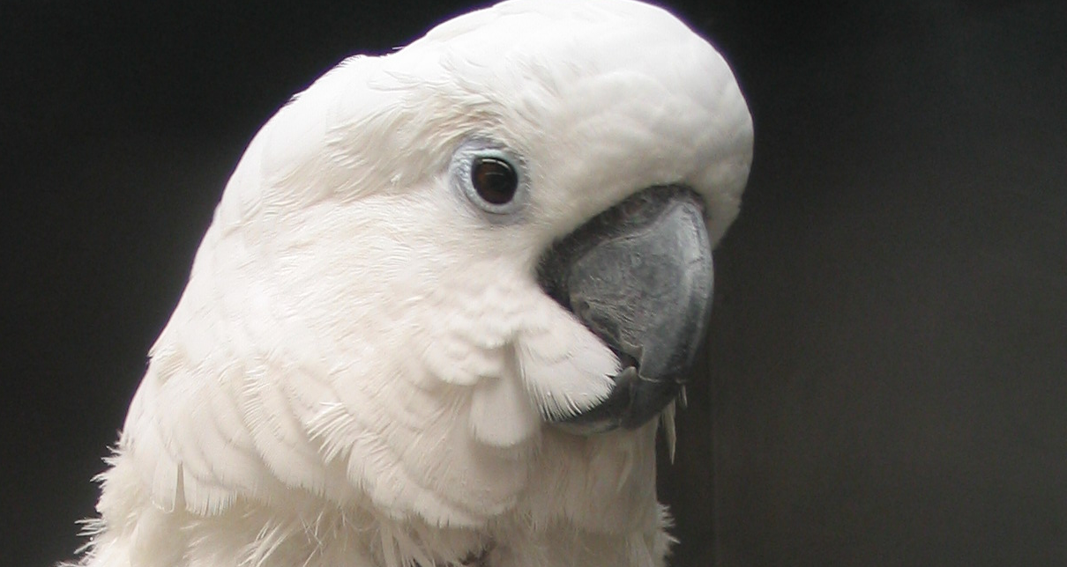
 | The body is flattened out in a horizontal position
 | Tail wagging or shaking of tail feathers
 | In cockatoos and cockatiels, the facial feathers may be fanned over the beak
 | “Tongue wiggling” is also commonly observed in cockatoos and cockatiels.
In tongue wiggling, the mouth is held slightly open and the upper and lower bills are quickly moved up and down, while the tongue moves in and out in a licking motion.

Persistently fluffed feathers, paired with lethargy, are signs of clinical illness.

Fear or Stress Postures

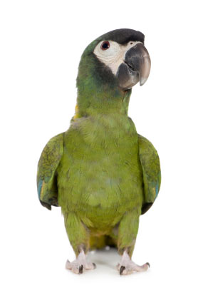 |  | The bird pulls itself up into a stiff, skinny posture.
 |  | The feathers are held flat against the body
 |  | Quivering wings are held slightly away from the body in a pre-flight position.
 |  | The head is held high and forward (some birds may jerk the head back and forth).
 | Pay careful attention to what causes stress or fear behavior in your bird. Whenever possible, remove or prevent the stimulus. If that is not possible (or desired), introduce the stressor gradually in a safe, secure manner.

Aggressive and Excited Postures

Excited and/or aggressive birds can display similar postures and similar behaviors. Before attempting to handle a parrot in this state, try to allow them to calm down first. After all, an overstimulated parrot can bite just as hard as an aggressive parrot.

To express excitement and/or aggression, some birds…

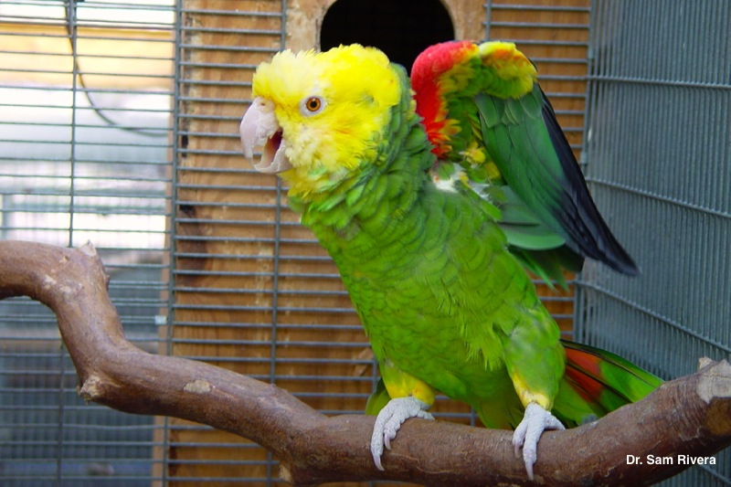 |  | Stand very tall, trying to appear as large as possible.
 |  | Spread the wings to display color accents.
 |  | Fan out the tail feathers
 |  | Erect feathers on the crest, nape, or colorful parts of the body. These feathers will stand out one-by-one or in groups, like the crest in the cockatoo and cockatiel

Consider a flaring tail to be a serious warning signal. Although this
behavior can be part of courtship displays, tail fanning is a sign of
extreme excitement in a parrot and can often be associated with
aggression.

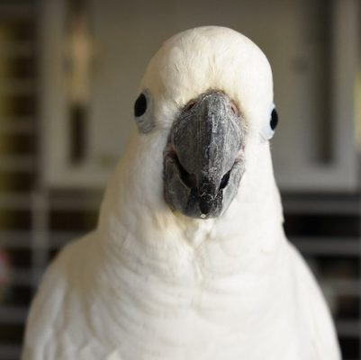 | 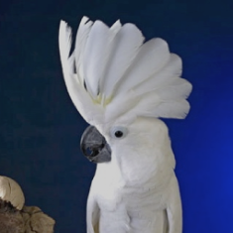

Cockatoos and cockatiels erect their crest feathers to communicate
excitement in response to both good and bad stimuli.

Additional signs of excitement and/or aggression can include…

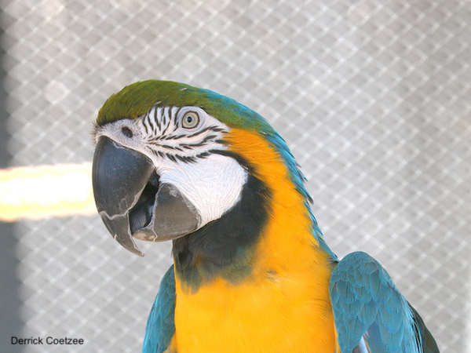 |  | Eye pinning, which is an extremely important sign of strong excitement, either good and bad.  Eye pinning, also known as flashing or pinpointing, is easily observed in light-eyed birds in which the pupils rapidly expand and contract down to a bare pinpoint, as the parrot becomes more and more excited.
 |  | Lowering the head and leaning the body horizontally
 |  | Holding the beak open, biting, or lunging forward
 |  | Wing flipping (this behavior can also simply be an effort to line the feathers up just so).
 |  | Foot tapping

Begging Postures

Begging or “Come Pick Me Up” postures can seem similar to aggression in some ways, but the bird gives off a contented attitude while…

Staring intently at someone or something
The plumage is usually fluffed, not stiff or tight
The body is flattened out in a horizontal, crouched position
Quivering wings are held out at the shoulder
The neck is often shortened with the head held up

Courtship Displays

Reproductive behaviors in the parrot are complex, and will not be covered in any detail here, however hen’s posture to communicate her receptivity to the male bird is similar to the “pick me up” posture. Other courtship displays can include eye pinning, tail fanning, and wings stiffly extended from the shoulders.
These Clues Are Not Foolproof

Unfortunately, we humans can misinterpret the messages expressed through our bird’s body language—especially when parrot behavior is new to us. Humans also aren’t the only beings capable of sending “mixed messages”. This is particularly true for younger birds, during their first 5-10 years of life. For instance, a parrot that craves attention may inadvertently be taught to bite or scream excessively if their social needs are not adequately met.

References and Recommended Reading

Athan MS. Reading parrot body language. In: Guide to a Well-Behaved Parrot, 3rd ed. Hauppage, NY: Barron’s Educational Series; 2007: 79-85.

Blanchard S. Reading body language. In: Sally Blanchard’s Companion Parrot Handbook. Oakley, CA: Abbey Press; 1999: 162-163.

Gaskins L. Diagnosis and treatment of aggression in pet birds. Proc Annu Conf Assoc Avian Veterinarians 2008.

Mancini JR. Why Does My Bird Do That? A Guide to Parrot Behavior, 2nd ed. Hoboken NJ: Howell Book House; 2007.

Spadafori G, Speer BL. Birds for Dummies. Hoboken, NJ: Wiley Publishing; 1999.

Welle K. Social behavior in psittacids: applications to companion birds. Proc Atlantic Coast Veterinary Conference 2002.

