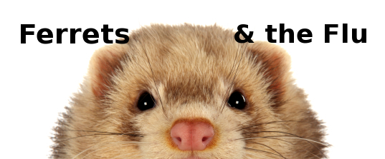

It’s flu season!

If you’re a ferret owner, that means extra worry about your furry little family member. Ferrets are susceptible to several strains of human influenza virus, which is spread through the air from coughing, sneezing, and other respiratory secretions. The virus is not only spread from human to ferret, but ferret to ferret and from ferret to human as well.

If you have the flu…

- Avoid close contact with your ferret and have another person provide his care during your illness, if at all possible.
- If you must handle your ferret while you’re sick, wash your hands before and after handling your ferret and avoid having him near your face. It may be a good idea to wear a surgical mask when you care for your ferret.

What does the flu look like in ferrets?

As in humans, symptoms of flu in ferrets usually begin with a fever. As the fever subsides, signs of upper respiratory illness ensue. Coughing, sneezing, thick nasal discharge, and watery eyes can all be seen. Affected ferrets often become lethargic and refuse to eat. Gastrointestinal signs, such as vomiting or diarrhea, may also be observed.

Most healthy adult ferrets recover within 7 to 14 days with proper care. Nutritional support and fluids, either oral or injectable, will be needed in most cases. Sometimes, your veterinarian may also prescribe cough suppressants, decongestants, and/or antibiotics. Very young or very old ferrets are most likely to develop life-threatening complications, such as pneumonia.

What should I do if my ferret develops signs of respiratory illness?

Quickly contact your exotic animal veterinarian when you suspect a respiratory illness in your ferret. Other diseases, such as heart disease and deadly canine distemper virus, can appear similar to influenza. Early treatment for many conditions can mean the difference between a quick recovery and devastating illness.
February 3, 2014

