PIGS AND DOGS:
A Recipe for Disaster

Dogs remain one of the most common household companions, and as miniature pigs grow in popularity as pets, the question invariably comes up: how might dogs and pigs get along in the same household? While it is possible to have pigs and dogs in the same home, they can also be a serious risk to each other in a domestic setting. It is critical that you, as a pet parent, understand the distinct natures of pigs and dogs and take precautions at all times. Most importantly, pigs and dogs should NEVER be left alone unsupervised for any length of time, no matter how well they get along or how closely they are bonded.

While there are certainly some pigs and dogs that do not mind each other's presence or even seem to enjoy each other's companionship, this is not always the case. Pigs and dogs can often be friendly when they are young. But while dogs stay fairly consistent in their temperament throughout their lives, pet pigs can go through many changes in temperament as they age. As the pig gets older, it may no longer tolerate companionship with the dogs in the household. Or the pig may challenge the dog, and eventually the dog will lose patience with the pig.

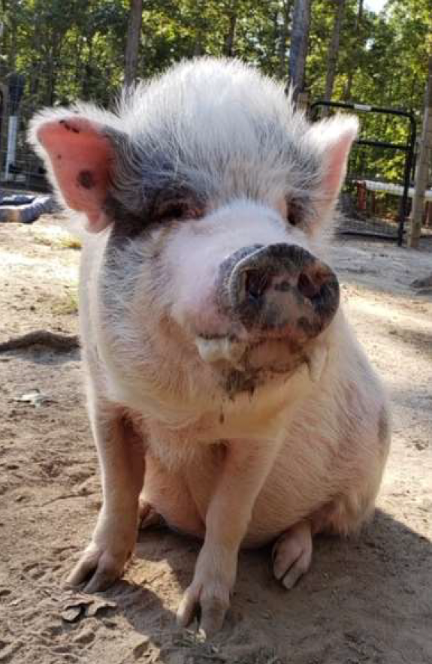 | Predator vs. Prey  In nature, dogs are predators and pigs are prey animals.  Normal pig (prey) behaviors, such as running away, charging, biting, challenging, or sounds, like squealing or screaming, can trigger a latent predator instinct in an otherwise docile and friendly dog.  We as humans already know this to some extent. Think about the types of toys we give dogs to play with; they are often modeled after small animals and make squeak or whistle sounds (prey type behaviors). We see the dog react to these noises by biting, shaking, and “attacking” the toy (predator-type behaviors). An otherwise calm and relaxed dog can be worked into a frenzy by a particularly appealing toy. This same reaction can potentially be triggered by a squealing pig, leading to a much more tragic outcome then just a ripped-up toy.

Herds vs. Packs

Many animals, both wild and domesticated, live primarily in social groups of their same species.
However, there are significant differences in the types of groups.
- Groups of predators, such as dogs, large cats, and wolves, are usually described as “pack” animals.
- Groups of prey animals are referred to as “herd” animals. Herd species are typically grazing animals subject to being hunted by pack animals, including many domestic
animals like cows, sheep, goats, and pigs.

While a pack is a group, it is typically significantly smaller than a herd or prey group. A pack works together consciously as a team in constant communication, and so it has fewer members. As pack animals, dogs are biologically programmed to create a largely unchanging social order with their packmates, maintained by mutual respect, communication, and clear body language.

A herd, on the other hand, functions largely without structure, with its members often acting in blind compliance with the majority for safety purposes. Herd animals don’t necessarily think about their reliance on their fellow animals, but rather are biologically programmed to have these companions. As herd animals, pigs are driven to continually challenge and reassess the order of the herd to ensure that the strongest remains on top to protect the herd as a whole from predators.

When translated into a domestic pet situation, this most basic instinctual difference can lead to stress on both the dog and the pig. The pig views the dog as another member of its herd, and so will challenge the dog to ensure the herd is safe. This type of challenge however, is not normal in a pack setting. To the dog, the pig’s challenge is viewed as unwarranted aggression, and the dog will react accordingly. This is when a fight occurs.  Even if the dog is submissive enough to walk away from the  pig’s challenge in that particular instance, the pig is then  confused. The pig feels that their safety is in question and will continue to challenge the dog in the future in an attempt to resolve this hierarchal issue.  These differing “world views” lead the dog to see the pig as a bully and lead the pig to feel the need to constantly check for their safety. This is essentially a “miscommunication” based on biology, but it can lead to tragedy. | 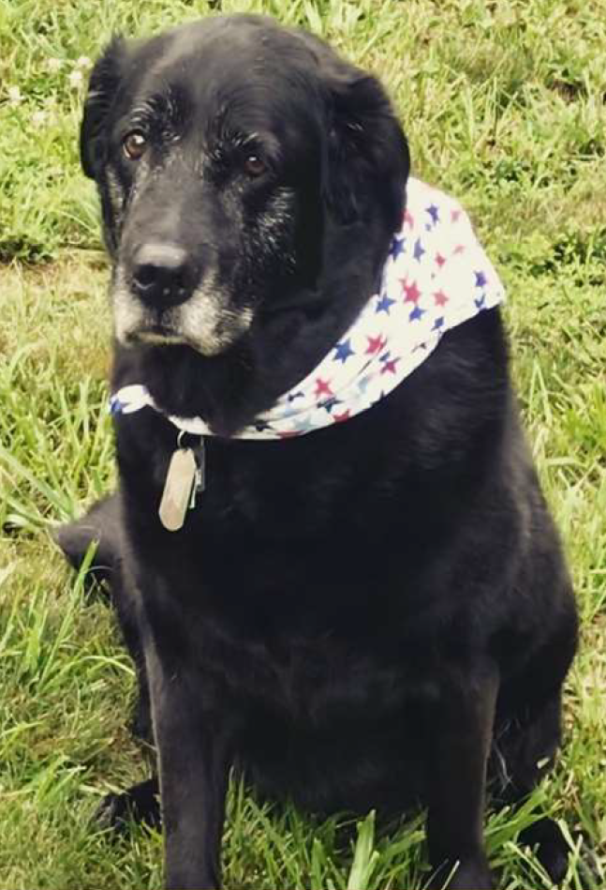

The Dog Will Always Win

Many people are in denial and believe that their dog(s) would never harm a pig. It doesn't matter
if the dog is well trained. The instincts discussed above will override training at the worst of times. If a dog is upset by a pig, it is natural for them to attack. It doesn’t mean that they are cruel or dangerous, just that they are a dog.
Pigs have no defense against the jaws of the dog. It only takes seconds for a dog to rip the ears off the pig and maul them, often resulting in the pig’s death or serious disfigurement. Many pigs have lost their ears, their sight, their hearing, or their lives to dog attacks from the otherwise docile family dog.

The only 100% effective way to prevent a tragic outcome is to ensure pigs and dogs are NEVER
left alone together.

References

Landsberg GM, Denenberg S. Behavioral problems of dogs. Merck Veterinary Manual online. May 2014. Available at https://www.merckvetmanual.com/behavior/normal-social-behavior-and-behavioral-problems-of-domestic-animals/behavioral-problems-of-dogs. Accessed April 29, 2021.

Landsberg GM, Denenberg S. Behavioral problems of swine. Merck Veterinary Manual online. May 2014. Available at https://www.merckvetmanual.com/behavior/normal-social-behavior-andbehavioral-problems-of-domestic-animals/behavioral-problems-of-swine. Accessed April 29, 2021.

Landsberg GM, Denenberg S. Social behavior of dogs. Merck Veterinary Manual online. May 2014. Available at https://www.merckvetmanual.com/behavior/normal-social-behavior-and-behavioral-problems-of-domestic-animals/social-behavior-of-dogs. Accessed April 29, 2021.

Landsberg GM, Denenberg S. Social behavior of swine. Merck Veterinary Manual online. May 2014. Available at https://www.merckvetmanual.com/behavior/normal-social-behavior-andbehavioral-problems-of-domestic-animals/social-behavior-of-swine. Accessed April 29, 2021.

Lawhorn DB. Management of potbellied pigs. Merck Veterinary Manual online. June 2013. Available at https://www.merckvetmanual.com/exotic-and-laboratoryanimals/potbellied-pigs/management-of-potbellied-pigs. Accessed April 29, 2021.

Lawhorn DB. Providing a home for a potbellied pig. Merck Veterinary Manual online. July 2020. Available at https://www.merckvetmanual.com/all-otherpets/potbellied-pigs/providing-a-home-for-a-potbellied-pig. Accessed April 29, 2021.

Matlock. Pigs & dogs a dangerous combination. Oct 6, 2014. Mini Pig Info Website. Available at https://www.minipiginfo.com/dangers-of-mini-pigs-and-dogs.html. Available at https://www.minipiginfo.com/. Accessed April 29, 2021. Accessed April 29, 2021.

Pollock, C. Basic Miniature Pig Care. LafeberVet Web site. July 18, 2019. Available at https://lafeber.com/vet/basic-miniature-pig-care/. Accessed April 29, 2021.

Ross Mill Farm. Pet Pig Myths and Facts. Ross Mill Farm website. July 15, 2019. Available at https://rossmillfarm.com/2019/07/pet-pig-myths-and-facts/. Accessed April 29, 2021.

