The Raccoon Roundworm

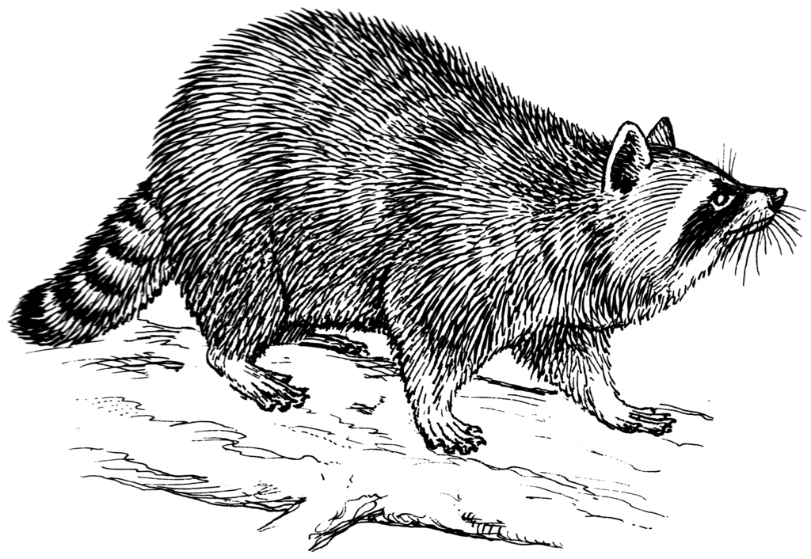  Image: Pearson Scott Foresman via Wikimedia Commons | The raccoon roundworm, or Baylisascaris procyonis, is a nematode commonly found in the North American raccoon. Adult female worms live in the raccoon intestinal tract. The presence of these worms almost never makes the raccoon ill, but roundworm eggs are shed in their feces. These eggs are not capable of transmitting infection at first. Instead, it typically takes 2-4 weeks for eggs to become infective. Eggs can survive in the environment for years, even after exposure to weather-related extremes.

Where is Baylisascaris found?

The parasite is widespread in raccoons in North America, particularly in the Northeast, Midwest, and West Coast. This roundworm has also been found in raccoons in the Southeast and Southwest US. Unfortunately, the raccoon roundworm has also been introduced to many parts of Europe and Asia due to the trade of live raccoons.

Why should I care about the raccoon roundworm?

Serious, sometimes fatal, raccoon roundworm infections have been reported in over 150 species of birds and mammals.

When humans accidentally ingest raccoon roundworm eggs, it is possible for parasite larvae to migrate to the brain, eye, and other internal organs, causing serious health problems and even death.

Who is most at risk?

- Young children, especially those 2 years and younger, are at highest risk of ingesting B. procyonis eggs because they are most likely to put contaminated fingers or soil in their mouths.
- Individuals with severe developmental disabilities are also at increased risk.
- Of course, those exposed to raccoons or their feces, such as wildlife rehabilitators, are also at risk for Baylisascaris infection.

What can I do to minimize the risk of exposure to raccoon roundworm eggs?

- Do not keep, feed, or adopt raccoons as pets.
- Closely monitor children at play to prevent ingestion of soil or exposure to raccoon latrines.
- Cover sandboxes when not in use, since raccoons will use these structures as latrines
- Keep children out of areas in which raccoons like to defecate, such as haylofts and attics
- Wash hands frequently with soap and warm, running water, particularly after exposure to raccoons or after working (or playing) outdoors.
- Discourage raccoons from living near your home by tightly closing trash containers, sealing off access to attics and basements, and clearing brush. Also consider removing fish ponds and bird feeders, since raccoons are attracted to these food and water sources.
- It takes a minimum of 11-14 days for roundworms to become infective. Therefore prompt identification and removal of raccoon feces also reduces risk. Raccoon feces is usually dark and tubular with a pungent odor, and it often contains small, undigested seeds or grains. Raccoon latrines can be found in a variety of locations, including the base or forks of trees, woodpiles, as well as fallen logs, stumps, or large rocks. Man-made surfaces favored by raccoons include decks, attics, rooftops, garages, and haylofts.

Can any other animal species transmit the raccoon roundworm?

- Domestic dogs are unique in that Baylisascaris infections can result in illness OR adult worms can live in the intestinal tract and lay eggs in a dog that appears perfectly normal. Therefore, dogs should be tested regularly for parasites and dewormed by a veterinarian when indicated.
- Also discourage your dog from eating feces since this is another way raccoon roundworm eggs can appear in dog feces.⁴⁴
- Close relatives of the raccoon, like the kinkajous and coatimundi, may also be able lay infective roundworm eggs. These species should be monitored like the domestic dog (see above).

REFERENCES

Blizzard EL, Yabsley MJ, Beck MF, Harsch S. Geographic expansion of Baylisascaris procyonis roundworms, Florida, USA. Emerg Infect Dis. 2010;16(11):1803-4. doi: 10.3201/eid1611.100549. PMID: 21029553; PMCID: PMC3294519.
Center for Disease Control and Prevention: Parasites – Baylisascaris infection: Prevention & control. Sep 28, 2018. CDC web site. Available at https://www.cdc.gov/dpdx/baylisascariasis/index.html. Accessed January 9, 2022.
Center for Disease Control and Prevention: DPDx - Laboratory Identification of Parasites of Public Health Concern. Baylisascariasis. June 13, 2019. CDC web site. Available at https://www.cdc.gov/parasites/baylisascaris/prevent.html. Accessed January 9, 2022.
Dunbar M, Lu S, Chin B, et al. Baylisascariasis: A young boy with neural larva migrans due to the emerging raccoon round worm. Ann Clin Transl Neurol. 2018;6(2):397-400. doi: 10.1002/acn3.694. PMID: 30847373; PMCID: PMC6389752.
Heller HB, Arnold S, Dreyfus JL. Baylisascaris procyonis central nervous system infection in a four-month-old Gordon setter dog. J Am Anim Hosp Assoc. 2019;55(3):e55301. doi: 10.5326/JAAHA-MS-6667. Epub 2019 Mar 14. PMID: 30870604.
Kazacos KR. 2016, Baylisascaris Larva Migrans: U.S. Geological Survey Circular 1412. 2016. doi: 10.3133/cir1412. Available at https://pubs.usgs.gov/circ/1412/cir1412.pdf. Accessed Jan 9, 2022.
Meteyer CU, Rogall GM. Fact Sheet 2017-3077: Information to prevent human exposure to disease agents associated with wildlife—U.S. Geological Survey Circulars on Zoonotic Disease. March 2018. USGS web site. Available at https://pubs.usgs.gov/fs/2017/3077/fs20173077.pdf. Accessed January 9, 2022.
Sircar AD, Abanyie F, Blumberg D, et al. Raccoon roundworm infection associated with central nervous system disease and ocular disease - six states, 2013-2015. MMWR Morb Mortal Wkly Rep. 2016;65(35):930-3. doi: 10.15585/mmwr.mm6535a2. PMID: 27608169.
Yabsley MJ, Sapp SGH. Prevalence of Baylisascaris in domestic dog coprological examinations in the United States, 2013-2016. Vet Parasitol Reg Stud Reports. 2017;9:65-69. doi: 10.1016/j.vprsr.2017.05.003. Epub 2017 May 20. PMID: 31014845.
Zajac AM, Conboy GA. Veterinary Clinical Parasitology, 8th ed. Ames, Iowa: Wiley-Blackwell; 2012: 58-59.

