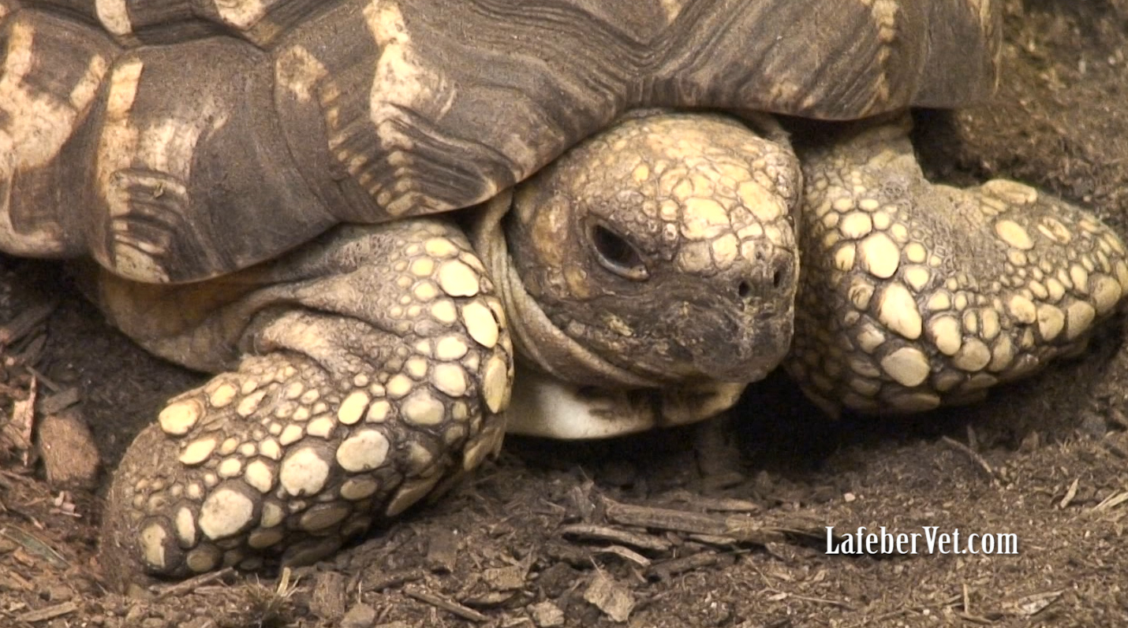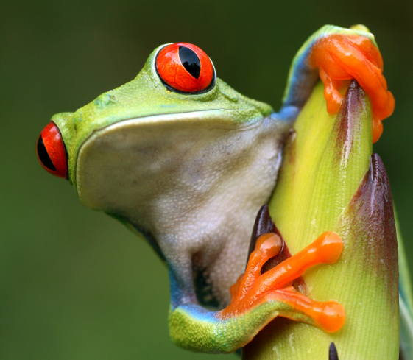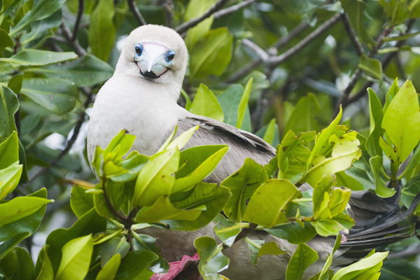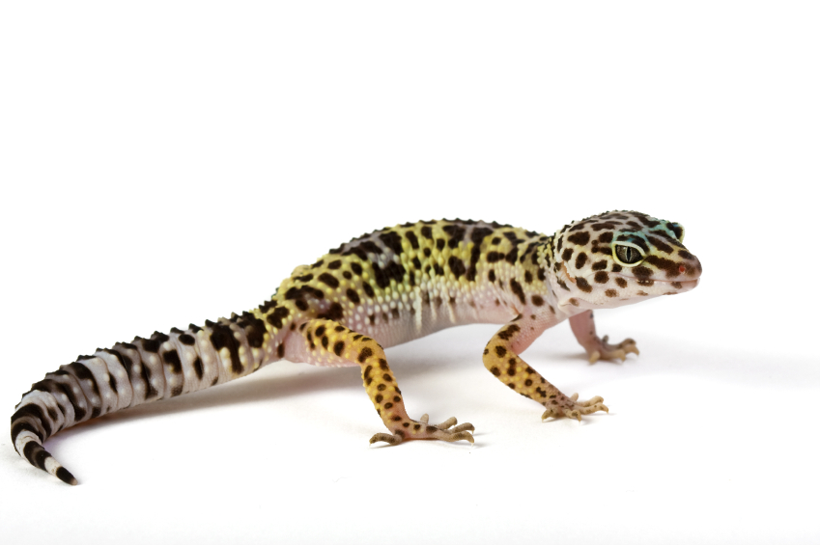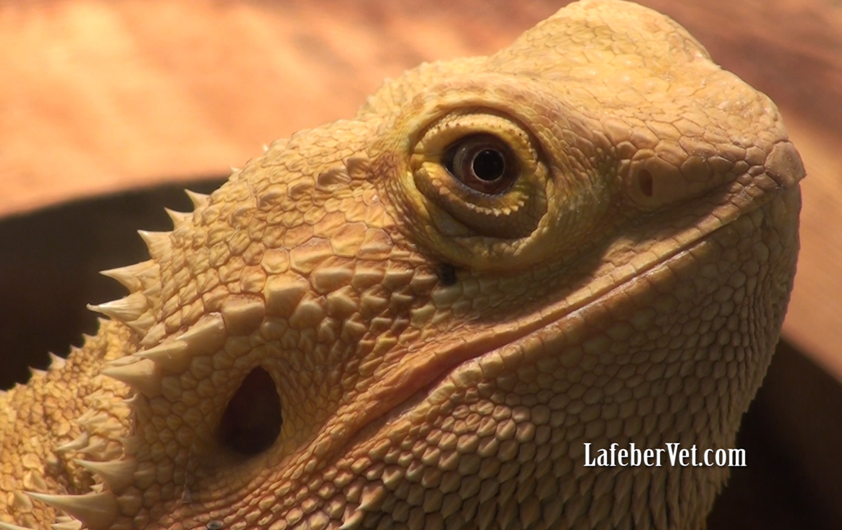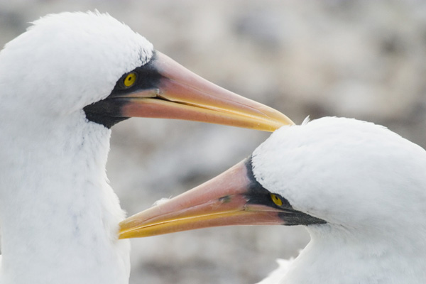

Who is most at risk?

*

*

*

How do I minimize my family’s risk?

How is Salmonella transmitted to humans?

Most reptiles/amphibians shed Salmonella

Transmission of disease can be direct: touching animal feces, then touching your face or putting your hand in your mouth.

*Salmonella* spp. may be spread through contact with the reptile/amphibian or its droppings. It has been said “*Simply having a reptile in the household increases the risk of infection” (*Mermin2004*).*

# **How is Salmonella transmitted to humans? reptiles/amphibians shed Salmonella**

What are the signs of salmonellosis in humans?

*

*Salmonella* spp. is part of the normal population of intestinal bacteria in reptiles and amphibians. Salmonella can be passed in the feces sporadically or continuously. Because animals appear normal, there are no warning signs that this potentially serious microbe is being shed.

*

There are estimated to be 13 million pet reptiles in American households. Arm yourself with all of the pertinent information about your pet, including facts about salmonellosis.

Know the Facts on Salmonellosis

#### Maecenus quis lacus?

# **Most reptiles/amphibians shed Salmonella Salmonella**

## Table of Contents

Responsible Reptile & Amphibian Ownership:

Client Education--Salmonellosis

In one survey, 45% of reptile-associated salmonellosis occurs in **children aged 5 years or younger**. The relatively weak immune system in kids paired with their poor hygiene practices **makes reptile ownership a significant risk in households with young children**.

Other immunosuppressed individuals at increased risk for contracting Salmonella infection include:

* Pregnant women and new mothers
* The elderly
* Patients on radiation, chemotherapy, or high doses of steroids
* The HIV-positive

# **What are the signs of salmonellosis in humans?**

# **Who is most at risk?**

**Indirect transmission** occurs when bacteria ‘hang out’ on an intermediate surface for a while. For instance, your reptile defecates in its cage, walks through its feces and then tracks stool (even just a few, dry fecal particles) onto your carpet. You later touch your carpet and then touch your face or mouth.

##### .

##### Signs of Salmonella infection in humans typically include diarrhea, fever, abdominal cramping and severe nausea. Unfortunately severe infections can develop in individuals with weak immune systems. These severe, deep-seated infections can lead to blood poisoning, meningitis, brain abscesses, infection of the heart muscle and even death.

**References and Further Reading**

American Pet Products Association. Industry statistics and trends. Mar 24, 2021. APPA web site. Available at <https://www.americanpetproducts.org/press_industrytrends.asp>. Accessed January 27, 2022.

Association of Reptile and Amphibian Veterinarians. Pet Owners: Learn how to safeguard yourself. Salmonella Germs in Reptiles and Amphibians. Nov 19, 2018. ARAV web site. Available at <https://arav.site-ym.com/global_engine/download.aspx?fileid=178A3026-E38E-4384-9743-41C5F6E936A0&ext=pdf>. Accessed January 27, 2022.

Centers for Disease Control and Prevention. Reptiles and Amphibians: Salmonella Infection. Sep 24, 2015. CDC web site. Available at [https://www.cdc.gov/healthypets/diseases/salmonella.html. Accessed January 27](https://www.cdc.gov/healthypets/diseases/salmonella.html.%20Accessed%20January%2027), 2022.

Johnson-Delaney CA. Zoonoses and Public Health. In: Diver S, Stahl S (eds). Mader’s Reptile and Amphibian Medicine and Surgery, 3rd ed. St. Louis, MO: Elsevier; 2016:1359-1365

Mermin J, Hutwagner L, Vugia D, *et al.* Emerging Infections Program FoodNet Working Group. Reptiles, amphibians, and human Salmonella infection: a population-based, case-control study. Clin Infect Dis. 2004;38 Suppl 3:S253-61. doi: 10.1086/381594. PMID: 15095197.

Meyer Sauteur PM, Relly C, Hug M, Wittenbrink MM, Berger C. Risk factors for invasive reptile-associated salmonellosis in children. Vector Borne Zoonotic Dis. 2013;13(6):419-21. doi: 10.1089/vbz.2012.1133. Epub 2013 Mar 8. PMID: 23473215.

**Regularly clean and disinfect your pet’s enclosure and cage furniture.**

It is particularly important to clean and disinfect the water bowl because it can serve as a petri dish allowing small numbers of bacteria to multiply tremendously.

**Never** eat, drink or smoke in animal areas**.**

Never house your pet anywhere near food areas.

Keep your hands away from your **eyes, mouth and nose**.

**Wash Your Hands.**

The single most important measure to prevent the transmission of infectious disease is hand washing with warm, soapy water. Wash your hands after handling not only your pet or its feces, but also its food, bedding or cage furniture. Wash your hands even when gloves are worn.

# **What can I do to minimize my family’s risk of contracting disease?**