CLIENT INFORMATION |  | LAFEBER COMPANY

Feeding your Parrot a Healthy Diet

Seed diets are deficient in vitamins, minerals and amino acids  In their native habitat, some parrots like cockatiels, budgerigar parakeets, as well as many cockatoos and macaws are seed-eaters. These birds are able to balance their diet because of the large numbers of seeds eaten (over 60 types).  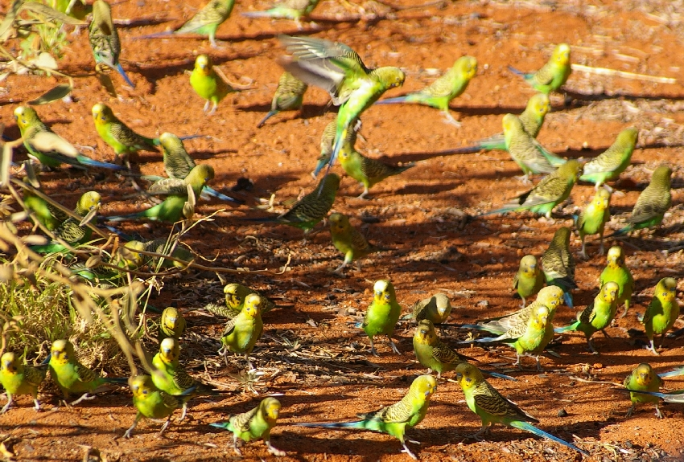  Companion parrots are often weaned onto all-seed diets, but the number and type of seeds offered in captivity is insufficient to offer a balanced nutrition. Commercial seed mixes lack the normal complement of nutrients including vitamins A, D₃, E and K, certain amino acids (the building blocks of protein), calcium, and other minerals. Over time, seed diets lead to vitamin A deficiency, poor feather quality, and weakening of the immune system, making your pet more susceptible to infections.  Changes in nutrient requirements  Birds have increased energy needs during growth, molt, and egg laying. Egg laying is associated with increased needs for dietary protein and calcium. There are also increased protein requirements during molt or feather replacement.  Do parrots need grit?  Some bird species, like pigeons and doves, or songbirds like canaries and finches, require grit for proper digestion. These birds swallow seeds whole, and the presence of grit in the gizzard helps to grind the whole seeds.  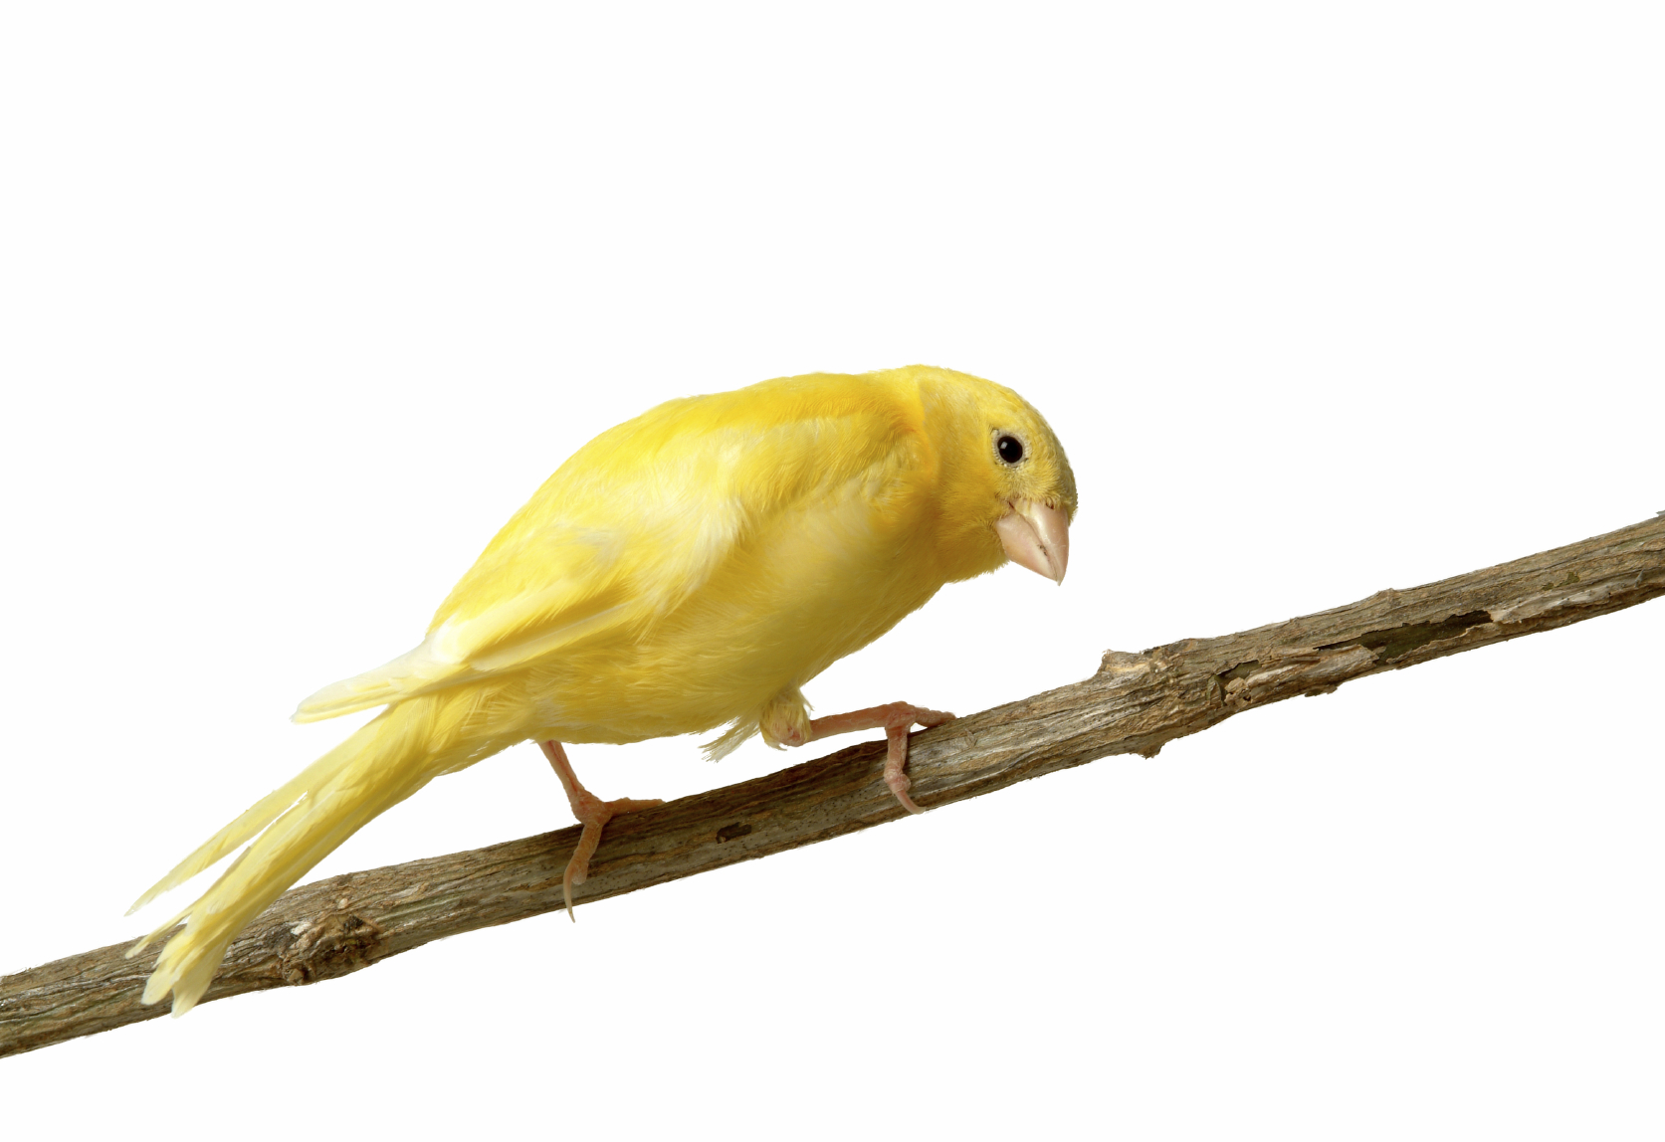  Since parrots remove the shell before swallowing seeds, they do not require grit. Ingestion of the occasional piece of grit is harmless, although the occasional individual will overeat grit when ill or stressed, potentially leading to intestinal blockage. | Healthy foods for the pet bird include:  - A high quality formulated food such as Premium Daily Diet Pellets™, Pellet-Berries™, Nutri-Berries™, and/or Avi-Cakes™.  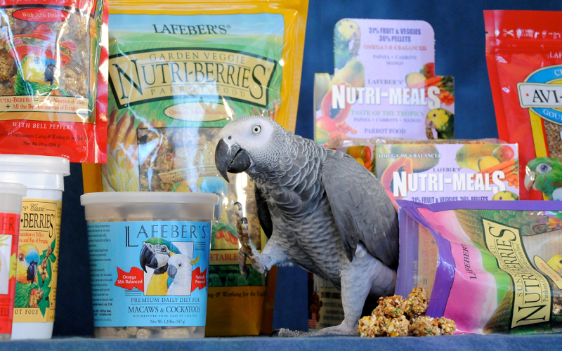  Formulated foods provide good nutrition in a convenient form, . however pellets and extruded foods should never make up the entire diet.  - Offer fresh vegetables and leafy greens daily. Yellow and orange vegetables and dark, leafy greens are an excellent source of vitamin A. Wash produce thoroughly.  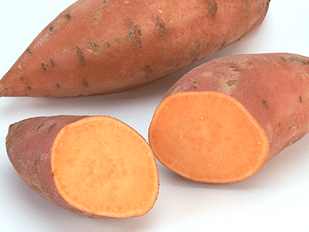  The physical and emotional health of your pet bird is affected by its diet  Feeding a balanced diet keeps your bird healthy and improves the sheen of its feathers. Intelligent birds like parrots also seem to require the mental stimulation that comes from foods with different shapes, textures, and colors.  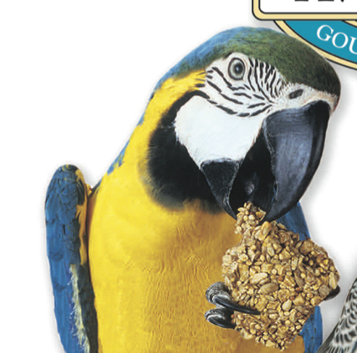 | - Dark, leafy greens and hard-boiled or scrambled eggs with the shell are also a great source of calcium.  If products are cooked, do not add salt, sugar, or fat such as butter or margarine to your parrot’s food.  Calcium is required in greater quantities than any other mineral and is need for healthy bones, normal metabolism, as well as eggshell calcification. A syndrome of low blood calcium is seen in some African grey parrots so it is particularly important to offer this species calcium-rich foods.  - Other foods that may be offered to pet birds in small amounts include:  - Whole grain products such as bread or toast, pasta, unsweetened cereal, wild rice, and wheat germ.  - Nutrient-dense fruits such as berries, mango, papaya.  - Nuts like palm nuts or walnuts  - A quality seed mix can be a part of a healthy diet, but should never be the main or sole source of food.
Two Generations of Veterinarians Caring and Working for the Health of Birds TM
Lafeber Company • 24981 North 1400 East Road • Cornell, IL 61319 • LafeberCares.com • 815.888.4040

