PHYSICAL EXAM AND TREATMENT

Species | Case #
Presenting Condition | Date
 | Examiner

 |  |  |  |  |  |  |  |  |  |  |  |  |  |  |  |  |  |  |  |  |  |  |  |  |  |  |  | Microchip?
 |  |  |  |  |  |  |  |  |  |  |  |  |  |  |  |  |  |  |  |  |  |  |  |  |  |  |  | Y |  |  |  |  |  | N
Sex: | M |  | F |  | U
Attitude | BAR |  | QAR |  | Depressed |  |  |  |  |  |  |  | Unconscious
Weight | ________ g/kg |  |  |  |  |  |  |  |  |  | Body condition: |  |  |  |  |  |  |  | excellent |  |  | good |  |  | thin |  |  |  |  | emaciated
Dehydration |  |  | Yes |  | No |  |  |  |  |  |  |  | %Dehydration |  |  |  |  |  | = |  |  | %
 |  |  | good |  | blood |  |  |  |  |  |  |  | discharge |  |  |  |  |  | discoloration |  |  |  |  |  | other
Mouth
Glottis
Tomia
Nares
Eyes R/L
Ears R/L
Respiratory: |  | normal |  |  | accelerated |  |  |  |  |  |  |  | slow/shallow |  |  |  |  |  | gasping |  |  | clicking |  |  |  |  |  | labored
CNS: |  | normal |  |  | abnormal (explain): ____________________________________________________
Movement: |  | normal |  |  | abnormal (explain): ____________________________________________________
Head position: |  | normal |  |  | abnormal (explain): ____________________________________________________
Epidermal: |  | normal |  |  | lacerations |  |  |  |  |  |  |  |  | punctures |  |  |  |  |  | abrasions |  |  |  |  |  |  | necrosis
Skeletal: |  | normal |  |  | mandibles |  |  |  |  |  |  |  | skull |  |  |  |  |  | joints |  |  |  | legs |  |  |  |  |  | shell

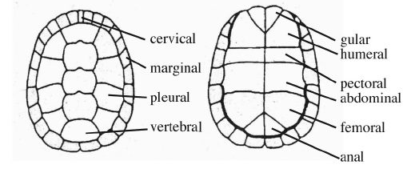

Image: Virginia Cooperative Extension

