UVB Lighting for Reptiles

Full-spectrum lighting is essential for reptile health

Sunlight, whether natural or simulated in a vivarium, is a vital resource. All wavelengths (ultraviolet-B, ultraviolet-A, visible light, and infrared) play an important role in reptile well-being and need to be present in appropriate intensities (Appendix 1). The light visible to reptiles includes ultraviolet-A (UVA), which enables full color vision in many species of reptiles. Visible light and short-wavelength infrared (IR-A) are responsible for the warming effect of sunlight.

UVB and vitamin D3
The best known role of ultraviolet-B (UVB) from sunlight is in enabling vitamin D₃ synthesis. Vitamin D plays an important role in maintaining calcium levels, primarily by enabling the absorption of calcium from the diet. Severe vitamin D₃ deficiency therefore results in a potentially life-threatening calcium deficiency. This essential mineral is instead extracted from the bones. When left untreated, this results in a condition known as nutritional secondary hyperparathyroidism or “metabolic bone disease”. The bones become weak from calcium loss and can easily break or become soft and bowed; limbs may become swollen, and the condition can be very painful. Growth is stunted in the young and bony deformities can result. If serum calcium levels fall to critical levels, weakness, lethargy, muscle tremors, seizures, and finally death will result.
Lighting requirements vary among reptile species
When housing reptiles in captivity our goal is to recreate their natural environment to the best of our ability. Does the reptile bask in full sun, like a bearded dragon? Or does it “mosaic bask” by exposing small amounts of its body to sun through foliage, like some chameleons? Or is it a nocturnal species, like many geckos and snakes, that are only exposed to daylight filtered through trees or rock crevices as it sleeps?

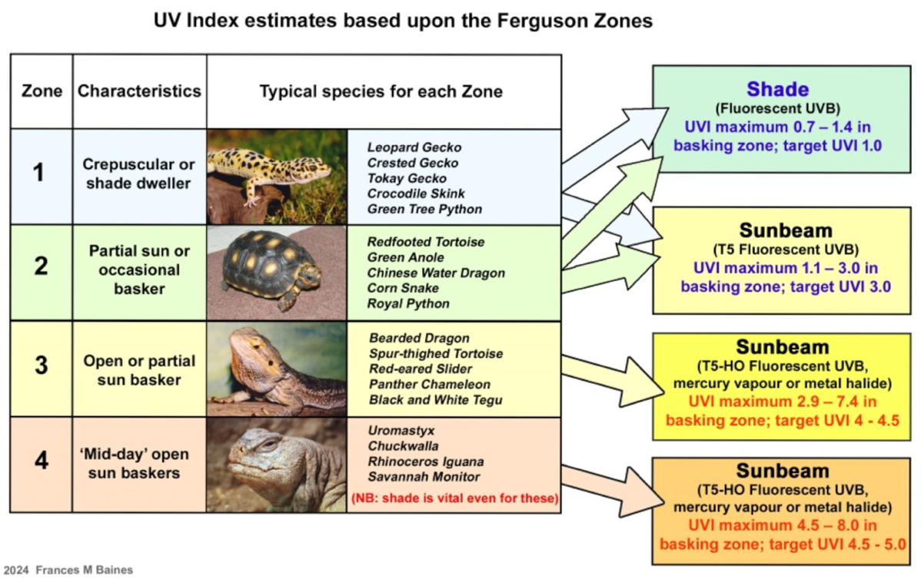

Figure 2. Reptiles can be assigned to one of four “ranges” of UV exposure based on their natural microhabitat and known basking behavior. Shown here, a simple “target figure” for the maximum UVI to be offered at reptile level is based upon the estimated UV Index during early to mid-morning, when basking behavior is most often observed. The UV index (UVI) is a measure of the intensity of light from a UVB lamp or sunlight using a Solarmeter® Model 6.5 or 6.5R UV Index Meter (Solar Light Company LLC)
Full-spectrum lighting that provides appropriate levels of UVB is now widely recommended for ALL species, for health and welfare reasons. Species that consume whole prey can utilize vitamin D₃ from their diet and do not appear to “need” UVB for normal calcium metabolism, although it is likely to be the main source of vitamin D₃ in wild reptiles, and has other beneficial local effects including enabling endorphin synthesis – providing the “feel-good factor” of sunlight. Lamps emitting UVB also provide UVA, which is part of the visible spectrum to reptiles, enabling full color vision.

Creating a “patch of sunlight”

No single lamp can replicate the entire solar spectrum, but a combination of lamps placed close together, with overlapping beams aimed at a “basking zone” below, can create a “patch of sunlight” that reptiles will recognize as such and respond to, accordingly. This combination will generally consist of three types of lamps:
- UVB-emitting lamp sold for use with reptiles, e.g. fluorescent UVB tube (UVB, UVA, & some visible light)
- Incandescent lamp, e.g. tungsten filament reflector or halogen bulb (infrared & some visible light create heat)
- Either a “white” LED strip or flood bulb or metal halide floodlight ( intense visible light)
Non-light-emitting heaters, such as ceramic heat emitters and “deep heat projectors” do not emit the wavelengths found in sunlight and are not suitable for use as basking lamps.

General guidelines

Lighting for captive reptiles is an ever-expanding area of research. We encourage every reptile owner to research their species of interest and to always ask your veterinarian if you have specific questions.

UVB rays are blocked by glass or plastic.
- Normal glass used for windows and vivariums blocks all UVB. Most transparent plastics either block all or a high percentage of UVB. When exposed to UV, translucent plastic also becomes brittle and discolored.
- NEVER place UVB lamps above glass or plastic sheets. Likewise, remove transparent plastic front covers or protective shields for a fluorescent lamp fixture or hood.
- Reptiles cannot benefit fully from sunlight that reaches them through a glass window. Although light and infrared rays can penetrate, no UVB gets through. NEVER place a glass tank in direct sunlight as the heat buildup can be rapidly lethal.
- UV-transmitting acrylic and glass do exist, for creation of skylights and outdoor shelters, but are expensive and hard to source. UV-transmitting acrylic (“sunbed acrylic”) is a specialist product that allows up to 80% transmission of solar UVB. Low-iron glass which allows up to 50% transmission is also available for special applications, under such brand names as Starphire® and Optiwhite®.
The “patch of sunlight” provided must be “just right”.
- The basking zone must be at least as large as the entire body of the lizard or chelonian or the shape of a loosely coiled snake. This ensures heat, light, and UV are spread evenly over the animal so that all parts of the body are exposed simultaneously with no “hot spots” likely to cause thermal or UV burns.
- However, to ensure an adequate heat, light, and UV gradient from “sun” at the warm end into “shade” at the cool end, the basking zone must not cover more than 50% of the enclosure.
The rays from lamps must overlap and lamps must be above the reptile.
- To recreate sunlight the strongest UVB rays need to blend with the strongest visible light and infrared, underneath the lamps. UVB rays are strongest beneath the middle of a linear tube.
- To avoid glare, stress, and possible eye damage, all lamps should be placed above the basking zone and aimed downward, not angled so that they are in the reptile’s line of sight.
UVB light will be partially filtered out by passing through mesh.
- Mesh screen tops and mesh lamp guards block a percentage of UV, light, and infrared. How much is blocked is determined by the thickness of the wire (physically blocking the light) and the size of the gaps between the wires. Different brands of mesh vary in both wire thickness and gap dimensions.
  - 0.64 cm (¼ in) wire mesh panels block approximately 25%
  - Exo Terra® and Zoo Med® screens and Arcadia LampGuardPro® tube guards block ~35%
  - Dubia Reptile Enclosures® and Zen Habitats® screens block 45%
- Owners of a UV index meter (Solarmeter® 6.5 or 6.5R) can simply use meter readings to adjust lamp placement above any screen. Alternatively, some charts are available showing lamp outputs at different distances for popular brands over mesh screens with varying transmission percentages (visit the “Reptile Lighting” Facebook Group Guides).
UVB bulb output decreases over time.
- The UVB output from all lamps decays with use. Decay is quite gradual in high-quality brands and many bulbs will provide adequate levels for approximately 1 year.
- The best way to monitor output is with the UV Index Meter (Solarmeter® 6.5 or 6.5R), taking measurements at reptile level at least monthly. Although meters are expensive up front, they can save money in the long run as bulbs may last much longer than expected and may not need annual replacement!
- If you do not have a meter, replace bulbs at regular intervals even if the visible light seems unchanged. Check the manufacturers’ guidelines. Annual replacement is recommended for all high-quality brands. Inexpensive products, often with unusual brand names or directly imported from China, are not recommended for use at all owing to great variability in UVB output and lamp quality, but if used, they may decay much more rapidly and might need replacing after only 3-6 months.

Lamps to AVOID

Every year many thousands of owners are sold lamps that are either totally useless or even possibly dangerous.
- Avoid lamps, usually fluorescent tubes or LEDs, claiming to be “full spectrum” but with no indication that they have any UVB content. These are often sold as “plant grow lights”, “bird lamps” or for human use for seasonal affective disorder (SAD). These lamps only emit a full VISIBLE spectrum, sometimes with a little ultraviolet-A (UVA). They are useless for vitamin D³ synthesis, but can be useful in boosting ambient light!
- HAZARDOUS: Cheap, small, halogen lamps, often sold direct from China, which have no protective front glass, just an unshielded halogen capsule which may emit un-natural UVB and UVC. Many varieties are sold from Amazon and eBay, often described as “UVB+UVA 3.0” or “all-in-one”, or sold pre-installed in attractive lamp holders.
- POSSIBLY HAZARDOUS: (1) The proposed ban of lamps containing mercury has led, understandably, to a rush to manufacture and sell UVB LED lamps which emit UVB and UVA as well as visible light. To date, no UVB LED has been tested on its ability to enable vitamin D₃ synthesis or for its long-term safety. (2) Mercury vapor UVB lamps with clear glass faces, mainly sold by little-known Chinese companies, typically have extremely tightly focused UV beams that fail to create adequate basking zones and may produce very small circles of extremely intense UVB, risking skin damage. (3) Although not necessarily emitting unsuitable levels of UVB, there are many cheap products sold online, typically direct from China or Hong Kong, which are copycat versions of established high-quality products. These low-quality, largely untested bulbs can have poor output and short lifespans. For example, a product by the Chinese company ReptiZoo® resembles the Arcadia ProT5® UVB Kits, but when tested, the ReptiZoo® version had a poor quality fixture and a T5-HO tube which suffered rapid decay in its UVB output.

Choosing a UVB lamp (Appendix 2)

Some definitions and misconceptions
Manufacturers typically categorize lamps according to their output at “typical” distances (e.g. 30 cm or 12 in below the lamp) – naming them “Desert” (higher output) or “Forest” (lower output) which can give rise to a lot of confusion. Theoretically, even the most powerful lamp could be used for low-level UVB if placed far enough away; and likewise a low output lamp at typical basking distances could provide high UVB at close range.

Another confusing label is the “percentage of UVB” for example, 6% UVB and 12% UVB, or 5.0 and 10.0 (representing 5% UVB and 10% UVB respectively). These figures don’t tell you anything about the intensity of the UVB you’ll measure at any given distance from the lamp. Instead they tell you the percentage of the lamp’s output which is UVB; the remainder being UVA and visible light. The higher the percentage, the more UVB available from a lamp of that brand, type, and wattage.
Linear UVB fluorescent tubes are the most versatile and widely-used UVB lamps sold for use with reptiles. The tubes are of two distinct types. T8 versus T5 designates the diameter of the bulb.
- A T8 tube is an older style, 2.5 cm (1 in) diameter tube that produces low-level, well-diffused UVB in all directions. If used with a good-quality aluminum reflector fixture, the output under the tube can be doubled; but even the 10%-12% UVB versions in reflector fixtures are best reserved for reptiles with low UVB requirements.
- T5 tubes are very slim (1.5 cm or 5/8 in diameter). Two versions exist: Standard Output (T5-SO, also called T5-NO) and High Output (T5-HO). High-quality aluminum reflector fixtures can boost the output under T5 tubes to threefold that of a bare tube. T5-SO tubes are low wattage, low output tubes, ideal for small terrariums and shade dwelling species. T5-HO tubes require higher wattage fixtures and are among the most powerful UVB lamps currently available.
Compact fluorescent lamps produce UVB only in a limited zone around the lamp, with a very steep gradient and intense UV close to the bulb. Often included in starter reptile kits , these lamps are not ideal for use with most commonly kept species owing to their limited coverage. They can provide UVB if mounted horizontally in a hood over a VERY SMALL terrarium where larger bulbs cannot be accommodated; however access to the mesh directly under the lamp MUST be restricted as the UVI can be dangerously high at such close range.
Mercury vapor UVB lamps are high-intensity discharge (HID) lamps that produce a combination of UVA, UVB, visible light and infrared. This is very old technology. Although the concept of an “all-in-one” lamp is appealing, they have significant drawbacks: (1) The arc tube produces a spectrum very unlike sunlight, with visible light mainly in purple and greenish-yellow, resulting in very poor color rendering. (2) They cannot be dimmed or put on a thermostat; if the lamp is turned off, the arc tube will need to cool down before it can be re-ignited. (3) Heat output is high, so they are unsuitable for smaller vivariums. (4) Quality and longevity is also a concern as UV output is notoriously inconsistent and incandescent filaments are fragile with a limited lifespan.
Metal halide lamps are HID lamps that create an extremely brilliant white light with excellent color rendering, plus UVA and some UVB. Although with some brands the UVB quickly decays, leaving a very high quality lamp providing exceptionally bright white light and UVA, which can last for several years. The main disadvantages are the requirement for an external ballast and good electrical wiring for a 4kV ignition pulse; inability to dim or use a thermostat, as well as difficulty in identifying a source. In the USA, the only existing brand sold for reptiles at the time of writing is the ZooMed® Powersun HID, a PAR36 70 watt lamp, and a matching ballast fixture. Commercially available non-UVB metal halides are still available and can make excellent sources of strong visible light, but like all HID lamps they are being replaced everywhere by LEDs.

For additional information visit:

“Reptile Lighting” Facebook Group: This online source provides a way to interact with other reptile owners and ask questions about any aspect of reptile lighting and heating. A section of the forum entitled “GUIDES” includes charts of the measured output of commonly-used T5 lamps, plus sets of articles covering issues such as the Ferguson zones, UVB LEDs, and infrared basking lamps, as well as links to relevant podcasts. The Admin team includes a small group of experienced reptile keepers and scientists involved in serious lighting research, as well as knowledgeable, long-term keepers happy to discuss any topics that come up. With 45,000 members worldwide, questions are often about basic care, posed by newcomers to the reptile world, but challenging new ideas are also discussed in depth.

UV Guide UK: The original Reptile Lighting website with information about UV, lights, UV meters, etc. Although now 20 years old, much of the information is still applicable.
ReptiFiles website: A useful site for prospective reptile owners or new keepers, by American author Mariah Healey, who describes herself as a "reptile husbandry researcher and consultant". Mariah has developed detailed “care guides” for some of the most popular reptile pets, which contain full descriptions of suitable lighting and heating equipment, and shorter “care sheets” for a wide range of other reptiles often kept as pets.
Mariah includes “shopping lists” using affiliate links for USA readers.

Solarmeter 6.5R UV Index Meter: Solar Light Company has distributors worldwide, including online stores.

Further reading
Baines FM, Cusack LM. Environmental lighting. In: Divers SJ, Stahl SJ (eds). Mader's Reptile and Amphibian Medicine and Surgery,, 3rd ed. 2019; St. Louis, MO: WB Saunders. Pp. 131-138.
Baines F, Chattell J, Dale J, et al. How much UV-B does my reptile need? The UV-Tool, a guide to the selection of UV lighting for reptiles and amphibians in captivity. Journal of Zoo and Aquarium Research. 2016; 4(1): 42-63. Available at https://www.jzar.org/jzar/article/download/150/89. Accessed Aug 20, 2024.

Barolet D, Christiaens F, Hamblin MR. Infrared and skin: Friend or foe. Journal of Photochemistry and Photobiology B: Biology. 2016;155:78-85. doi: doi: 10.1016/j.jphotobiol.2015.12.014.

Bertolucci C, Frigato E, Foà A. The reptilian clock system: Circadian clock, extraretinal photoreception, and clock-dependent celestial compass orientation mechanisms in reptiles. Biological Timekeeping: Clocks, Rhythms and Behaviour. 2017; 223-239. doi: 10.1007/978-81-322-3688-7_10.

Ferguson GW, Brinker AM, Gehrmann WH, et al. Voluntary exposure of some western‐hemisphere snake and lizard species to ultraviolet‐B radiation in the field: how much ultraviolet‐B should a lizard or snake receive in captivity? Zoo Biology. 2010;29(3):317-334. doi: 10.1002/zoo.20255.

Ferguson GW, Gehrmann WH, Vaughan MS, et al. (2021). Is the natural UV zone important for successful captive propagation of the Panther Chameleon (Furcifer pardalis); are different UVB irradiance exposures that generate a similar dose equally successful?. Zoo Biology. 40(2):150-159. doi: 10.1002/zoo.21591.

Fleishman LJ, Loew ER, Meal M. Ultraviolet vision in lizards. Nature. 1993;365:397. doi: 10.1038/365397a0.

Hoby S, Wenker C, Robert N, et al. (2010). Nutritional metabolic bone disease in juvenile veiled chameleons (Chamaeleo calyptratus) and its prevention. The Journal of Nutrition. 2010;140(11), 1923-1931. doi: 10.3945/jn.110.120998.

Holick MF. (2016). Biological effects of sunlight, ultraviolet radiation, visible light, infrared radiation and vitamin D for health. Anticancer Research. 2016;36(3), pp.1345-1356. Available at https://ar.iiarjournals.org/content/anticanres/36/3/1345.full.pdf. Accessed Aug 20, 2024.

Karsten KB, Ferguson GW, Chen, TC, Holick MF. Panther chameleons, Furcifer pardalis, behaviorally regulate optimal exposure to UV depending on dietary vitamin D3 status. Physiol Biochem Zool. 2009;82:218–225. doi: 10.1086/597525.

Oonincx DGAB, Diehl JJE, Kik M, et al. 2020. The nocturnal leopard gecko (Eublepharis macularius) uses UVb radiation for vitamin D₃ synthesis. Comparative Biochemistry and Physiology Part B: Biochemistry and Molecular Biology. 2020; 250:110506. doi: 10.1016/j.cbpb.2020.110506.

Sievert LM, Hutchison VH. Light versus heat: thermoregulatory behavior in a nocturnal lizard (Gekko gecko) Herpetologica. 1988;44(3): 266 -273 https://www.jstor.org/stable/3892340.
Tosini G. The pineal complex of reptiles: physiological and behavioral roles. Ethology Ecology & Evolution. 1997; 9(4):313-333. doi: 10.1080/08927014.1997.9522875.

Wacker M, Holick MF. Sunlight and Vitamin D: A global perspective for health. Dermato-endocrinology. 2013; 5(1):51-108. Available at https://www.tandfonline.com/doi/pdf/10.4161/derm.24494. Accessed Aug 20, 2024.

Watson, M. K., & Mitchell, M. A. (2014). Vitamin D and Ultraviolet B Radiation Considerations for Exotic Pets. Journal of Exotic Pet Medicine, 23(4), 369-379 https://www.sciencedirect.com/science/article/abs/pii/S1557506314001566

Wunderlich, S., Griffiths, T., & Baines, F. (2023). UVB-emitting LEDs for reptile lighting: Identifying the risks of nonsolar UV spectra. Zoo Biology. 2023; 43(1):61–74. doi: 10.1002/zoo.21806.

Appendix I. The primary effects of different parts of the sun’s spectrum on the reptile body: The light visible to reptiles includes ultraviolet-A (UVA), which enables full color vision in many species of reptiles. Both the spectrum and the intensity of light reaching the animal stimulate areas of the brain responsible for setting circadian rhythms and activity levels, and the pineal gland’s production of hormones regulating numerous bodily functions. Visible light and short-wavelength infrared (IR-A) from sunlight are responsible for its warming effect; IR-A penetrates deeply and also upregulates genes controlling cell multiplication and healing processes including the immune system. Natural levels of ultraviolet-B (UVB) also have direct beneficial effects on skin, killing bacteria, fungi and viruses, modulating the skin’s immune response, stimulating endorphins (the “feel-good factor”) and increasing pigmentation. The best known role of UVB from sunlight is in enabling Vitamin D3 synthesis.
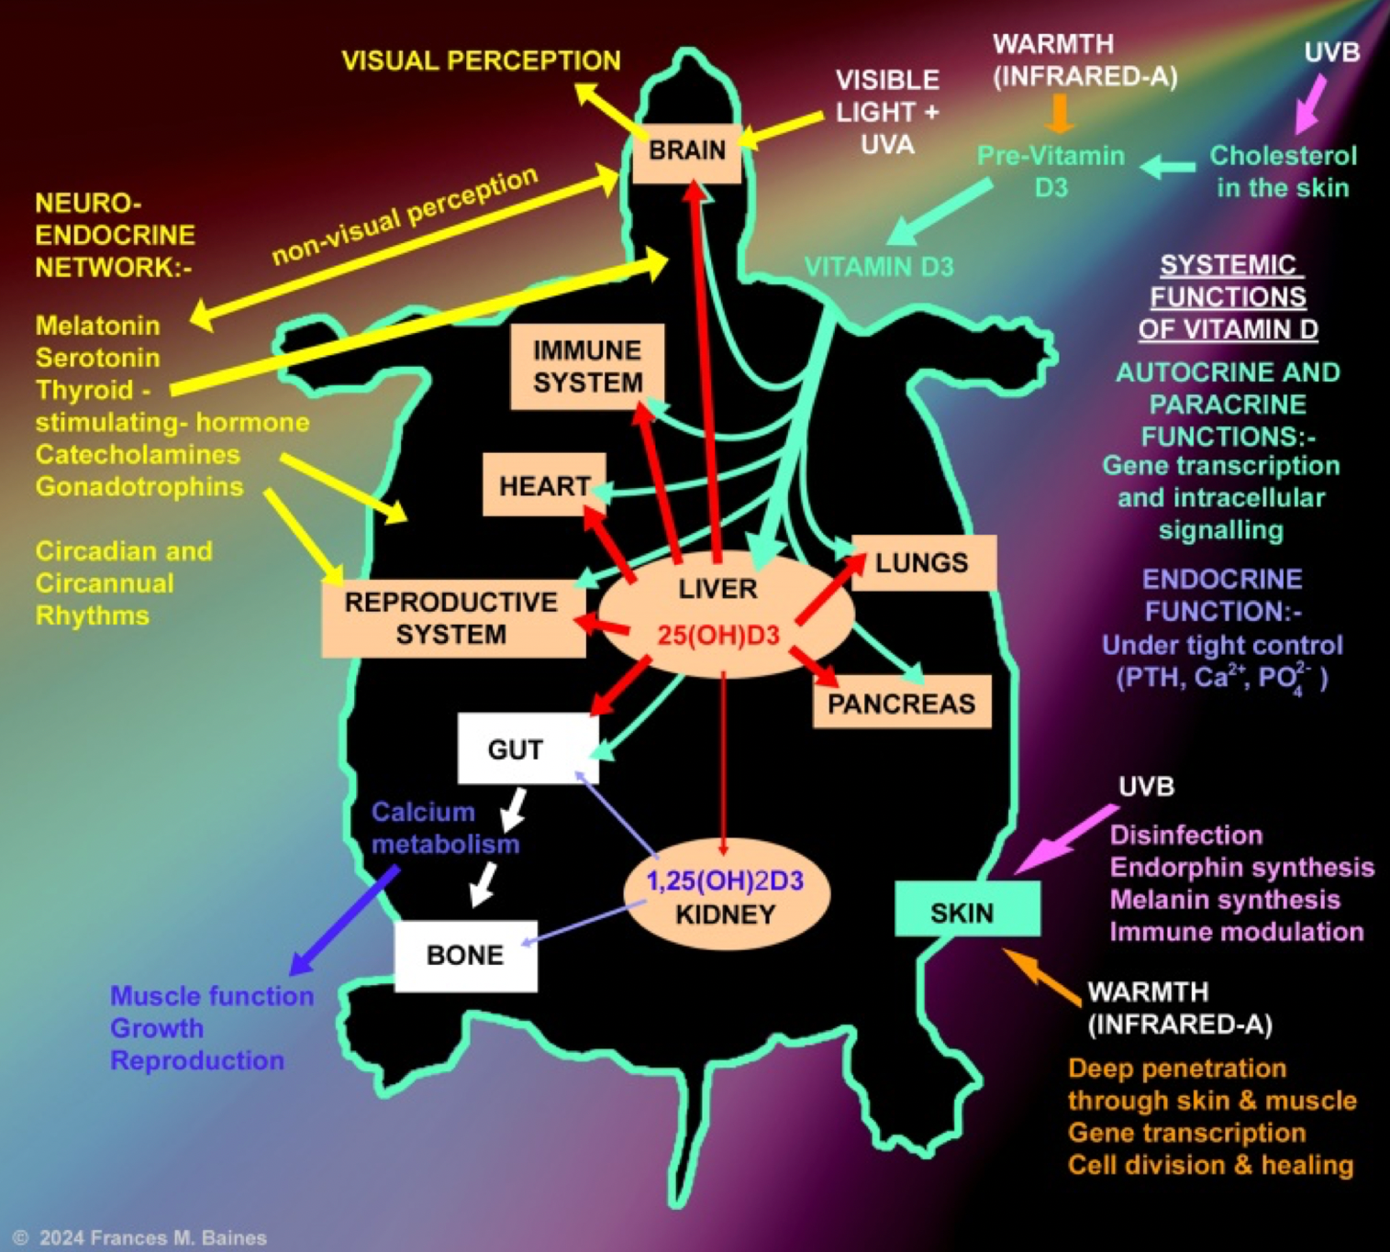

Appendix 2. Use this flow chart as an aid in selection of an appropriate linear fluorescent tube
